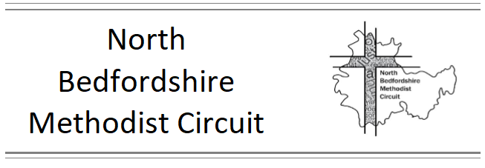
Charity number 1129523

Circuit Policy for callers to churches and manses

Who are these guidelines for?
Everyone including Ministers, Stewards and Congregations

Why have they been given to us?
The guidelines are designed to keep everyone safe and help us respond well as individuals, churches and a circuit to those visiting or calling at churches and manses asking for help with a wide variety of needs. This might include with food, travel, housing etc.

Where should they be kept
The guidelines should be made available at a suitable location in the Church such as the vestry so that they can be referred to easily should the need arise. Some individuals may also find it helpful to keep a copy for reference.

The Guidelines
Please do not give out money – money collected in the church is not ours to give and we have a duty of care to those who might be vulnerable to ensure they can come to church without feeling they might be asked to respond in this way
Please do refer people to the Food Bank – in Bedford Stephanie can issue vouchers as can other local agencies and towards Biggleswade ministers can contact The Need Project to refer people
Please do learn about and make use of the Benevolent Fund – this can be used to purchase things such as food, top up of gas or electric and travel tickets, but cash cannot be given from this fund. Some places have other local funds that can be accessed by clergy for people living in that area.
Please do make sure that your church has some items of food that could be given out if needed. It is helpful if these have good dates and at least some items do not require any facilities such as kettle or microwave.
Please do think very carefully before going anywhere with someone – never go alone, make sure others know where you are going and be aware that there may be implications for insurance if you are using your car.

What else can I do?
There are times when we might need to refer people to other agencies who can best help. A table listing help for those who are homeless in the broad area of Bedford is available and ministers have received this on email. Learning about the help available locally is also a really good thing to do. Some rural areas now have community agents who can help with a range of support, Citizens Advice is available in some areas and many of the night shelters and food banks are able to signpost to other help and support.

