***LONDON ROAD METHODIST CHURCH***

***20 OCTOBER 2024***

***Scripture passage this week: Acts chapter 2 verses 1 to 11***

***The Holy Spirit comes on the day of Pentecost.***

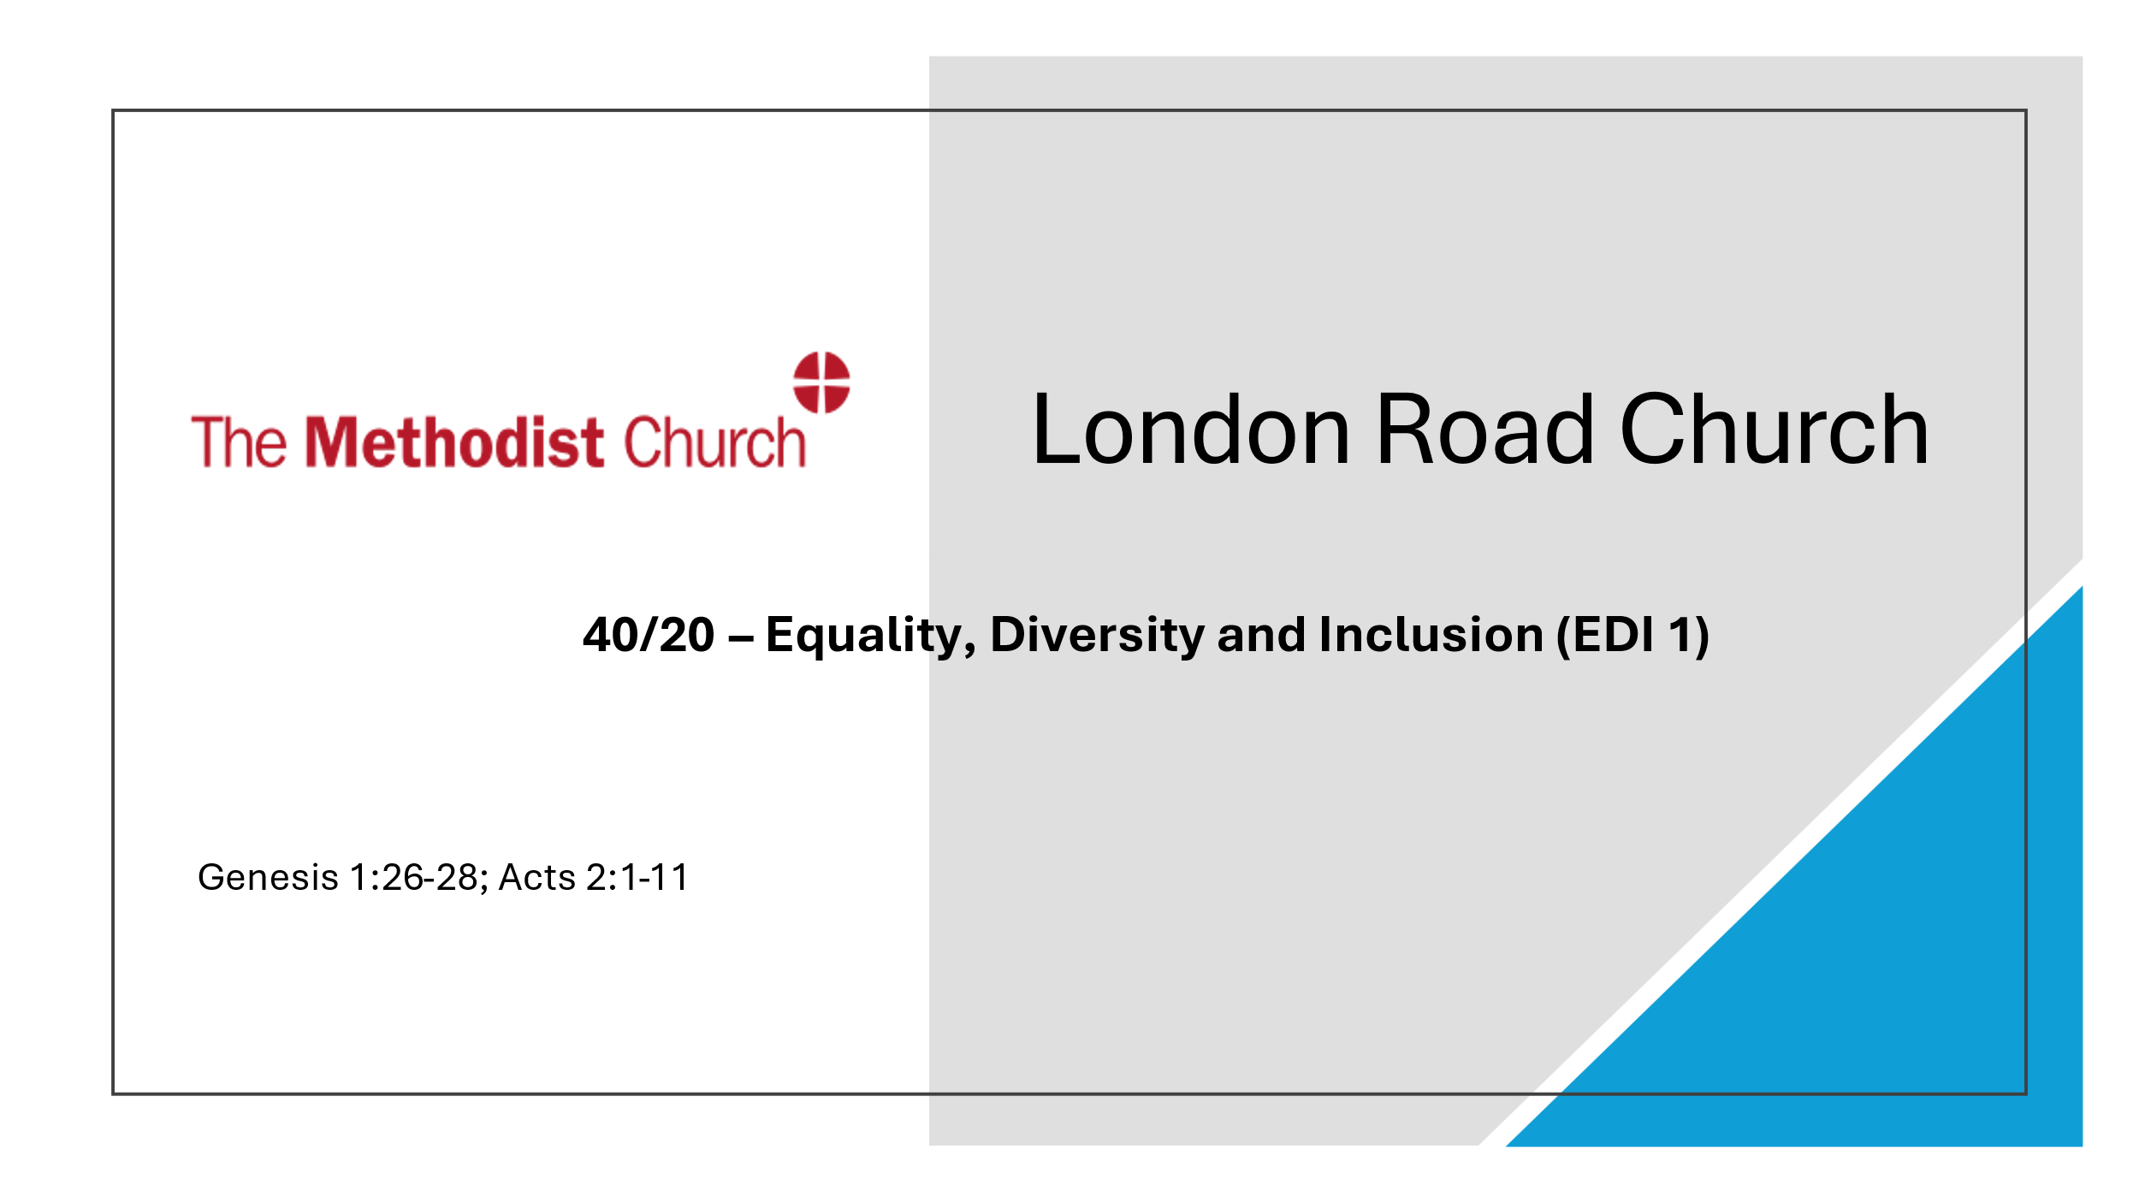

***This afternoon’s 40/20 service…..***

… is being led by our Minister, Rev. Chris Sandy. The service will include the first part of our Equality, Diversity and Inclusion (EDI) training. The underlying Scripture passages are Genesis chapter 1 verses 26 to 28 and Acts chapter 2 verses 1 to 11.

***Church Council***

If you are a member of the Church Council please find time to read the reports beforehand as no printed copies will be available at the meeting this Wednesday.

***Community Club***

Our recreational Community Club is back for its second session this Friday evening. Please come along and try your hand at table tennis, pool, chess and other activities – or just chill out over a cuppa and have a good natter. And bring your friends!

***The week ahead***

Wednesday 7 pm Church Council

Thursday 9.15 to 11.15 am Jolly Tots

Friday 7 to 9 pm Community Club

***Our Sunday services for the next few weeks***

*A 10-minute time of prayer is held in the lounge starting 20 minutes before the service.*

October 27th 10.30 am Mr. Chris Fox

November 3rd 2.30 pm Café service led by ourselves

November 10th 2.30 pm Rev. Chris Sandy (Remembrance Sunday Holy Communion)

November 17th 10.30 am Mr. Ebo Ofori-Quaah

***From the hymn book***

Bring the hopes of every nation; bring the art of every race. Weave a song of peace and justice; let it sound through time and space. *Delores Dufner (1991)*

*Our prayer bowl is available on the table near the front of the church for your prayers.*

*Monetary offerings for the church can be placed on the plate at the back of the church.*

*Any donations of items for the Food Bank can be placed in the large box in the vestibule.*

*Bedford Food Bank uses the hall as a distribution point on Thursdays from 1.30 to 3.30 pm.*